[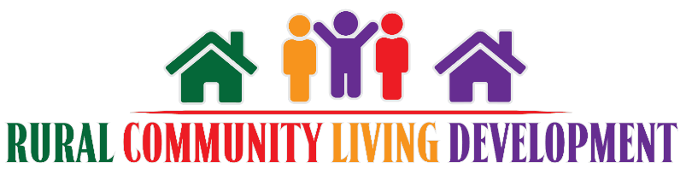](https://ruraloutreach.ruralinstitute.umt.edu/)

# Community Resources Worksheet

This activity can help you first generate a list of what you already know and serve as a prompt for talking with others to add to the list of people and resources.

First, list potential people and resources who might help with your efforts. This can include family, friends, businesses, and other potential supporters such as board members, ministry teams, tribal leaders, or Research and Training Centers.

Next, for each person, think about how they might support your efforts and place their names under the appropriate categories.

## In-kind goods:

(goods like snacks, space, equipment)

## In-kind services:

(printing or time, like an instructor who will lead adaptive yoga)

## Funding:

## Potential collaborators on grants:

## Volunteering time:

## Evaluation:

## Public relations:

## Spreading the word:

## Helping with events that raise awareness or donations:

## Organize or attend existing community committees/groups/coalitions:

## Assistive technology:

## (e.g., FM transmitter/headphones, large print formats)

## Transportation:

## Childcare: